1. Install Power BI Desktop and share the final screenshot of the report view page which appears when power desktop starts.

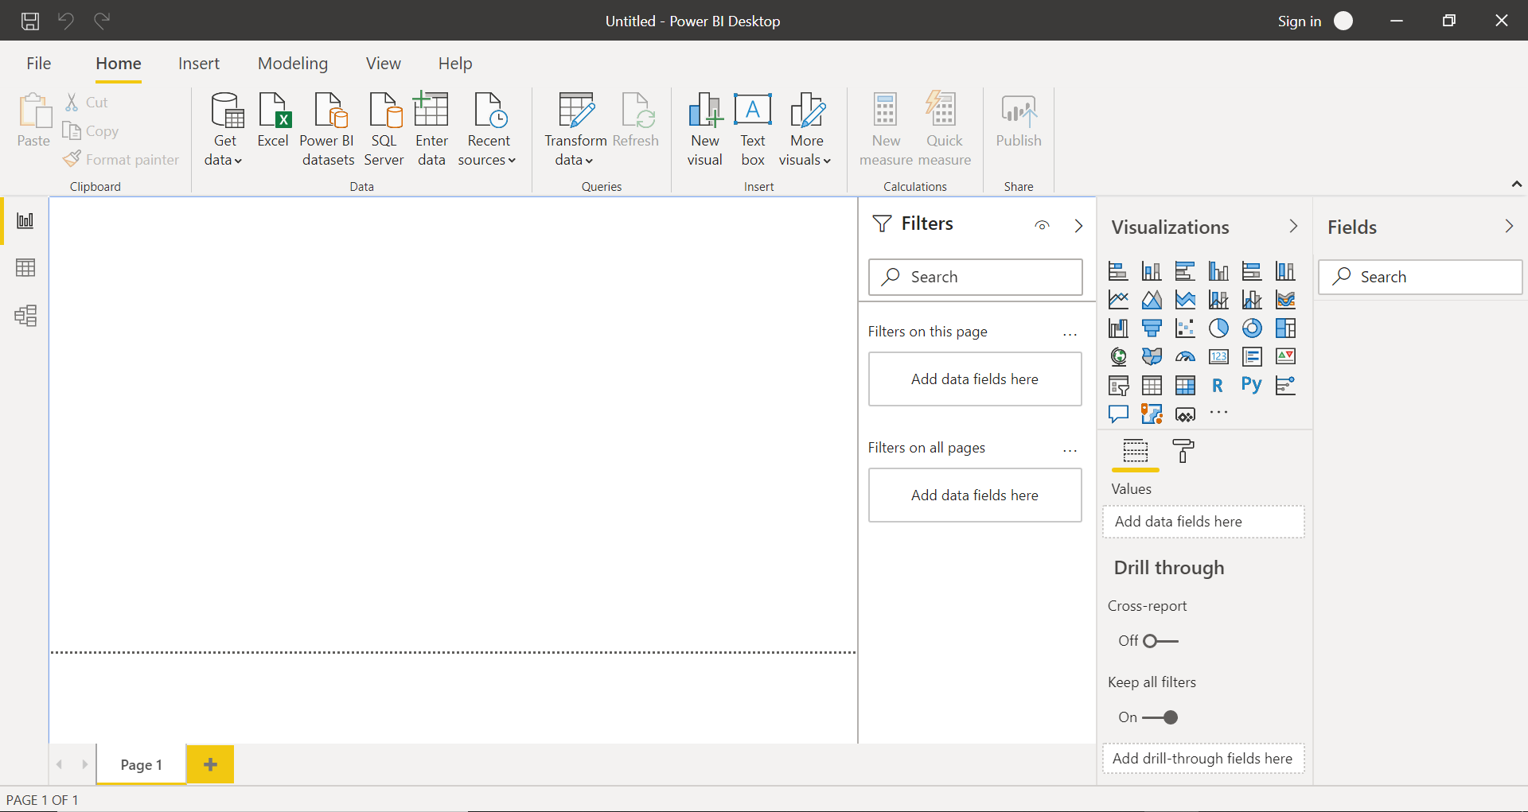

1. Prepare a document and with the following screenshot

**Report View**



**Data View**

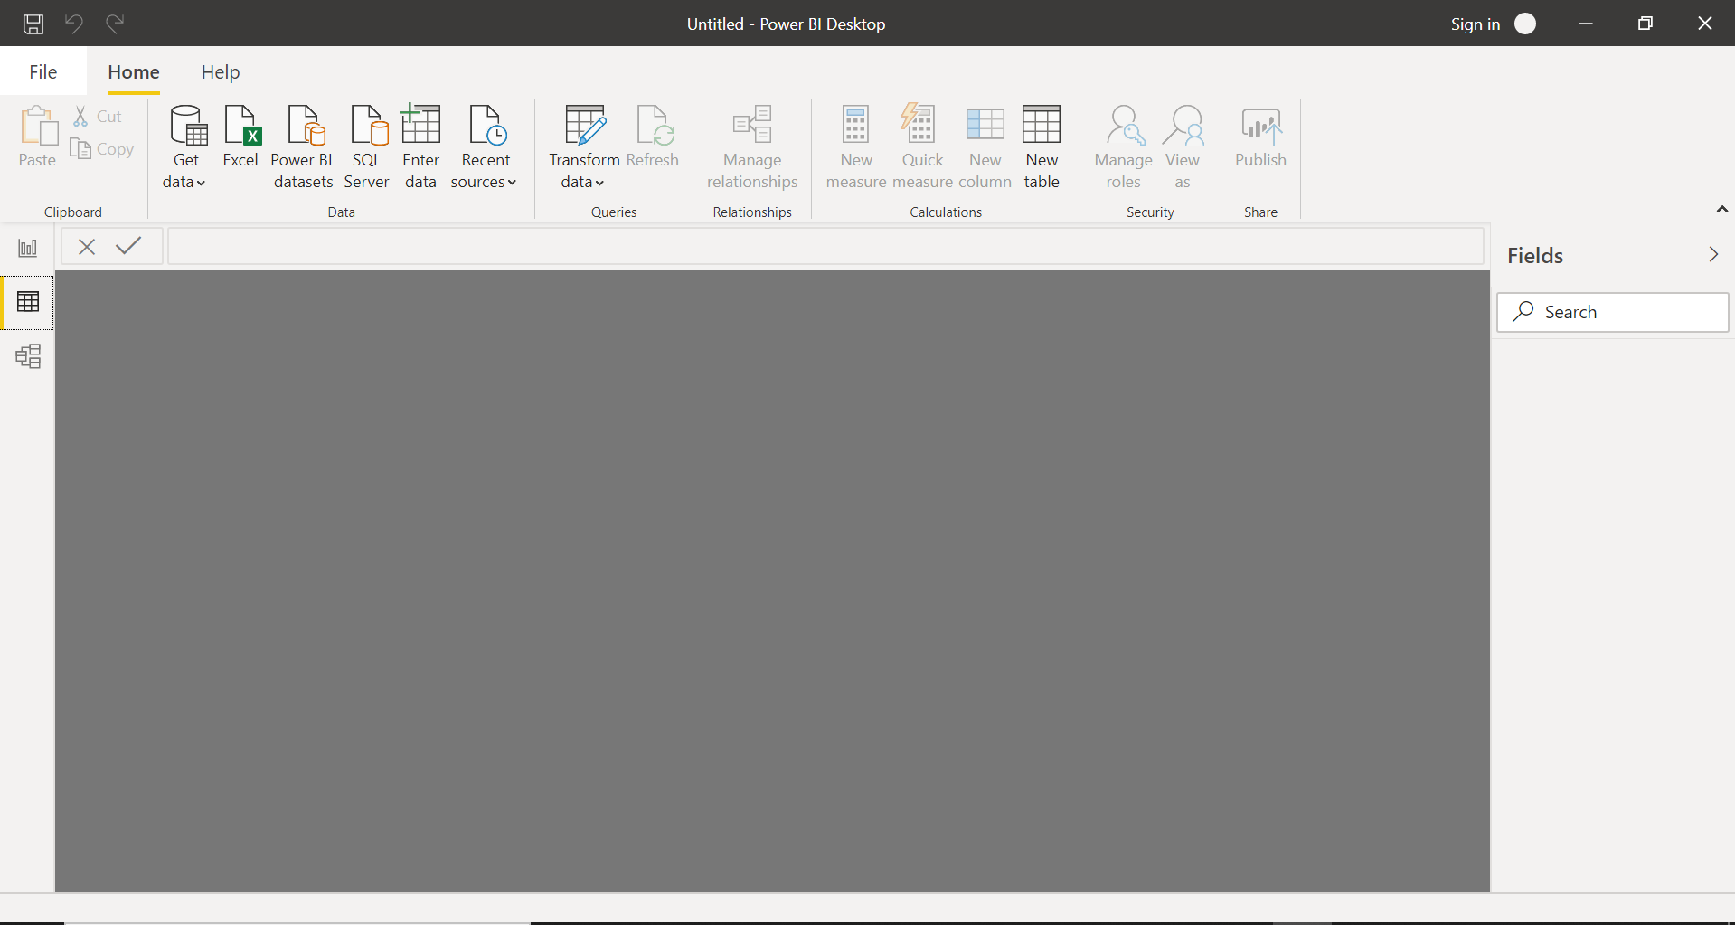

**Model View**

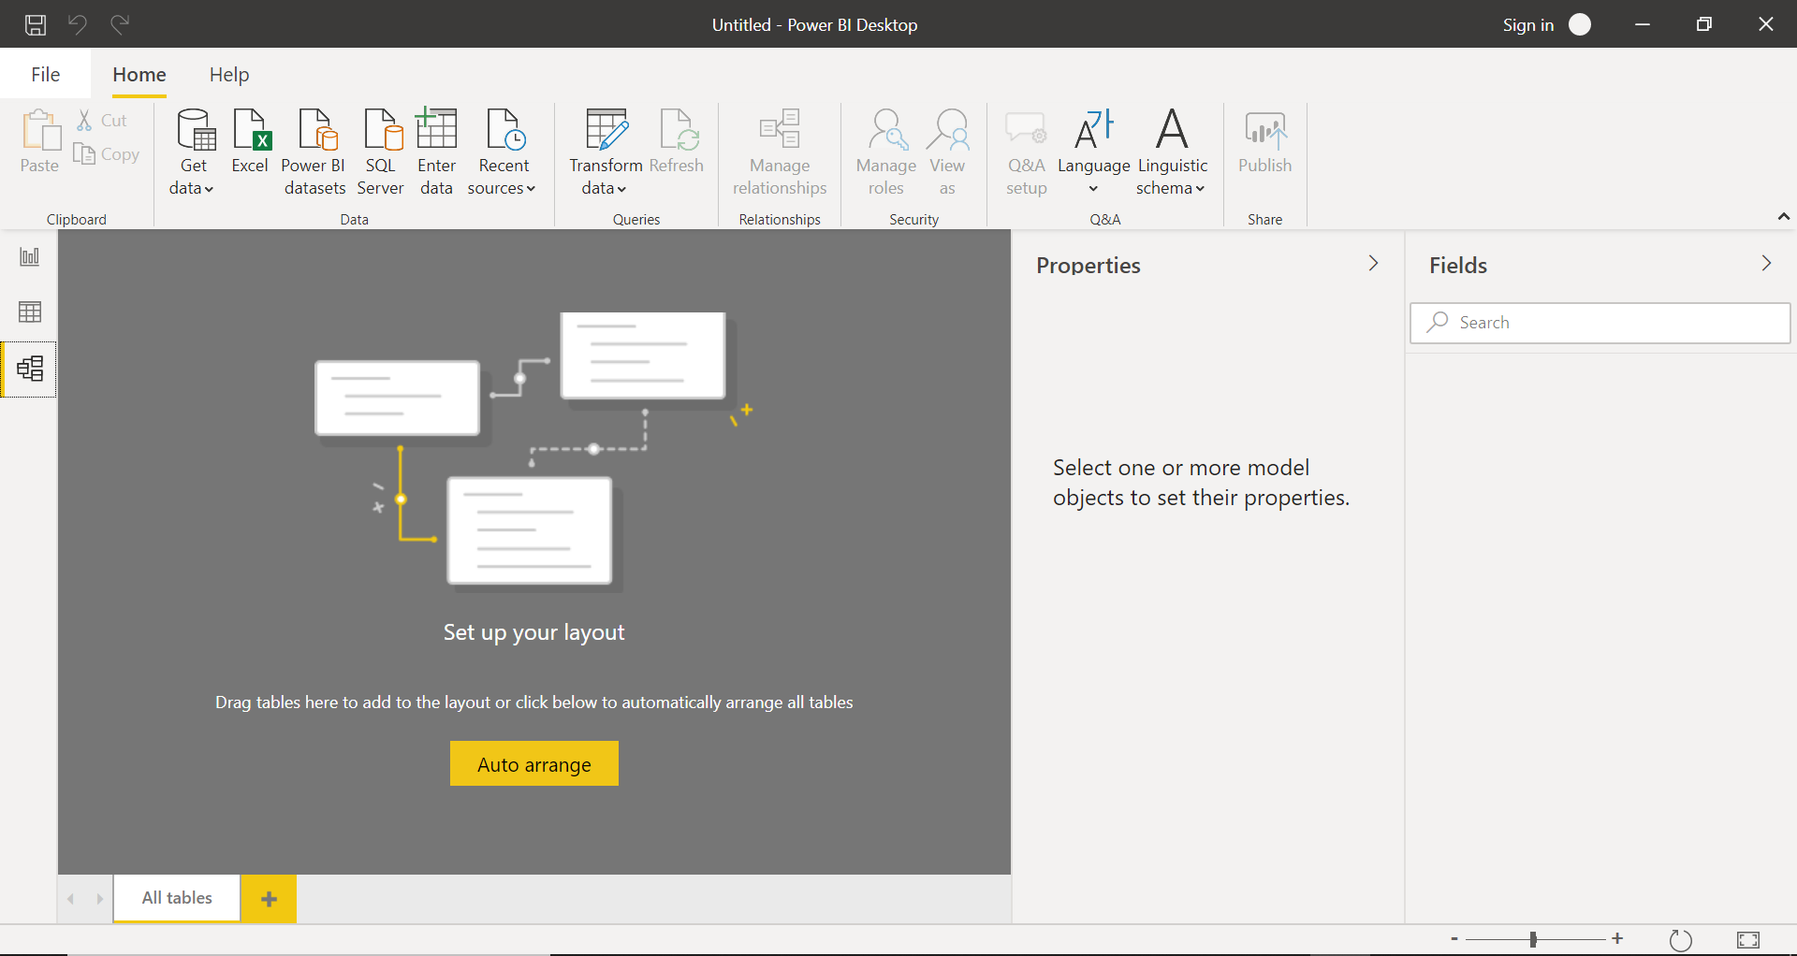

**Power Query Editor**

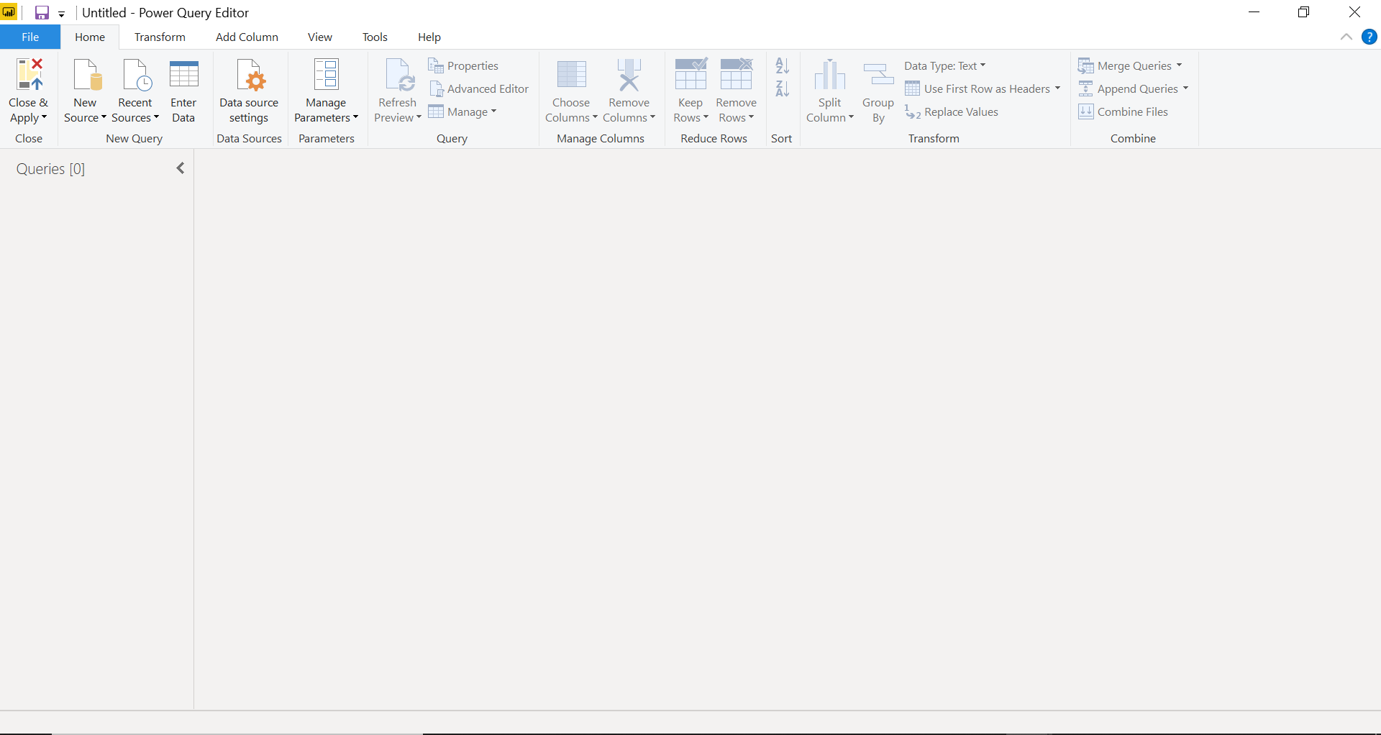

**Advance Editor**

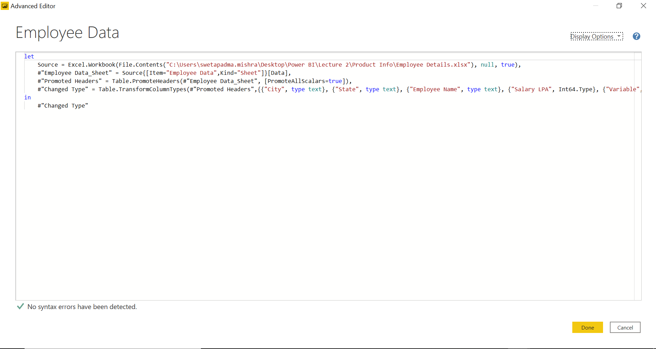

1. Prepare a document with details of the following along with their price

|  |  |  |
| --- | --- | --- |
| **Power BI Tools** | **Details** | **Price** |
| Power BI Desktop | It is a free version of Power BI used to consolidate data sources, create reports and conduct the required analysis.  It can be helpful to auto-detect and create data relationships between tables and formats.  It can connect and import data from over 70 cloud-based and on-premises sources. Storage limit of 10 GB per user.  Some limitations – It can’t share created reports with non-Power BI Pro users. No App Workspaces, API embedding, email subscriptions, peer-to-peer sharing, support to analyze excel in power BI desktop. | Free |
| Power BI Pro | It is a full version of Power BI which has the ability to use Power BI for both building dashboards and reports and unlimited viewing, sharing and consumption of the created reports.  It can embed Power BI visuals into apps (PowerApps, SharePoint, Teams, etc).  It is used for native integration with other Microsoft solutions (Azure Data Services).  App Workspaces and peer-to-peer sharing is possible via Power BI Pro.  It is licensed for individual users. So, it will be very expensive for usage of a lot of users. | $9.99 monthly/user |
| Power BI Premium | Power BI Premium is the most expensive tier of Power BI currently available and very distinct from the other two versions available on the market.  It has increased data capacity limits and maximum performance.  One API surface can be accessed by Power BI Premium.  It can embed Power BI visuals into apps (PowerApps, SharePoint, Teams, etc).  It has larger storage sizes for extended deployments. Geo distribution, higher refresh rates, isolation, pin to memory, read-only replicas are some of the features only Power BI Premium users can get.  One can purchase Premium in a range of capacity sizes that offer different numbers of memory and virtual cores that can scale as data analysis requirements change. | $4,995 monthly/user |